Land of Lincoln Planning Commission
209 West High Street, Hodgenville KY 42748 (270) 358-0830
Rezoning Application
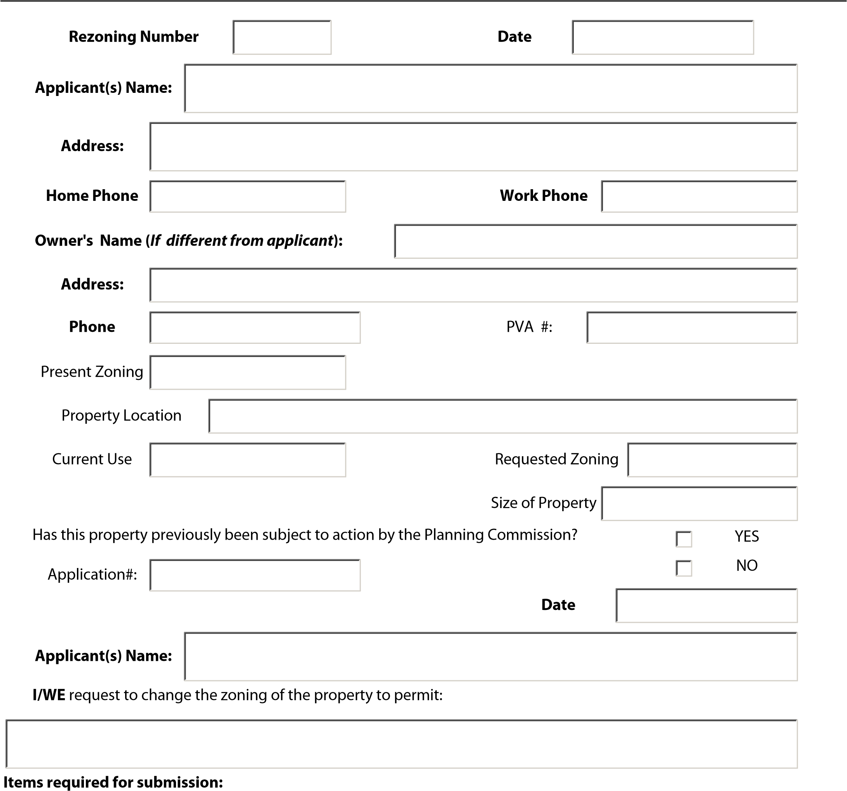
- $350 Rezoning fee. $1500 for Special Called Meeting
- Legal Description, Development Plan or Recent Survey or Record Plat of Property showing the dimensions and location or existing and/or proposed developments.
- List of all adjoining property owners and addresses. This information is available from the PVA office in the Courthouse. See next page.
- Copy of PVA Map showing the subject property.
- Completed Application.

Applicant’s Certification:
I do hereby certify that the information provided herein is both complete and accurate to the best of my knowledge and I understand that any inaccuracies may be considered just cause for invalidation of this application and any action taken on this application. I further certify that I am the owner of the subject property or that I have the authority to file this application based on properly executed documents with the owner of the subject property.
Date Applicant's Signature:
Owner’s Certificate: (complete if applicant is not owner of the subject property.)
I do hereby certify that as owner of the property proposed for map amendment in this application. I am aware of the proposed use, application, and map amendment process required by the Land of Lincoln Zoning Ordinance and KRS 100.
Date Owner's Signature:
ADOINING PROPERTY OWNERS
NAME ADDRESS PVA #

